# AEGIS NET: Protecting the Earth

# Project Summary:

AEGIS NET (Asteroid Emergency Guidance and Information System Network) is a two-interface emergency response system that was developed to address the threat of near-earth objects such as the Impactor-2025. Even though NASA and USGS data sets may provide valuable data on asteroid and environmental data, existing instruments are remote and either too technical or simplistic. This gap is bridged by AEGIS NET which incorporates real-time NASA NEO and JPL data with USGS geologist and environmental data and transforms raw science into interactive graphics, simulations and practical applications. The platform empowers the people and the professionals too to be aware of the scenarios of asteroid impact, predict the consequences and research on mitigation actions.

The system offers multi-interfaces AEGIS COMMAND, a decision support dashboard, for scientists, policymakers and emergency managers, and AEGIS GUIDE, a public facing interface, intended to teach and prepare people to be safe. COMMAND provides AI-powered impact model, mitigation testing and allocation, and GUIDE provides individualized safety advice, evacuation plans, and multilingual directions. Its own process of complex planetary defense data becoming available and accessible, as well as educational and actionable via advanced simulation and intuitive design, AEGIS NET will help to create a global preparedness and engage individuals in planetary defense.

# Problem Statement:

The fact that there are near-Earth asteroids such as Impactor 2025 demonstrates the presence of the actual danger of catastrophic impacts, which may result in tremendous environmental, economic, and human damages. Although NEO program of NASA and USGS datasets are important sources of orbital, geological, and hazard data, they are still quite fragmented, technical, and inaccessible to most users.

The existing tools are mainly concerned with detection and tracking, and they are not equipped to simulate the impact consequences, evaluate mitigation strategies, and have an intuitive way of risk communication. Policymakers are deprived of working decision support systems and the citizens lack clear actionable guidance. This deficiency restricts our capacity to plan, act and counteract any possible impact of asteroids.

# Objectives:

The primary objective of the present project is designing and developing AEGIS NET, interactive decision-support and educational tool that enables the policymakers and the general population to understand, predict and respond more effectively to the potential cases of asteroid impact. The project will assist in bridging the knowledge gap among hard to comprehend astrophysical knowledge and vulnerability-best informational content practice by integrating NASA Near-Earth Object ( NEO) datasets with USGS environmental and geological data.

In particular, the goals are:

1. **Data Integration:** Strategy is to integrate and standardize real-time NASA API astronomical objects (e.g. NeoWs, Small-Body Database) data with environmental data (e.g. USGS elevation and seismic activity) to create a stable foundation of impact simulations.
2. **Impact Simulation & Visualization To model:** With scientifically verified scaling to fundamental physics and orbital mechanics, the physical effects of asteroid impacts, such as crater formation, blast radius, seismic effects, and also the tsunami propagation, and present them in a visual form, in 2D and 3D, to be able to access them.
3. **Mitigation Strategy Testing:** To provide a platform to discuss the various asteroid deflection and mitigation methods (ex: kinetic impactor, gravity tractor, nuclear deflection) and to test them within various parameters.
4. **Decision Support to Policymaker:** To support evidence-based decision-making, AI-based evacuation routes mitigation suggestions, distribution of shelters and resources were provided through a supported emergency management dashboard (AEGIS COMMAND).
5. **Public Engagement and Education:** To create a popular interface (AEGIS GUIDE) that to transform technical simulations into easily readable and comprehended multilingual safety instructions, preparedness checklists, risk actions tailored to different communities.
6. **Scalability, Accessibility:** To ensure that the platform can be implemented in a global way and can be used in case of an emergency, be mobile-friendly, and inclusive, multilingual and telling educational information, with clear illustrations, and explanations.

# Methodology & Approach:

The development of **AEGIS NET** followed a multi-phase methodology that combined scientific modeling, data integration, system engineering, and user-centered design. Our approach was designed to balance scientific rigor with public accessibility, ensuring the platform serves both experts and non-experts.

**1. Data Integration & Preprocessing**

We began by identifying and integrating relevant datasets:

* **NASA NeoWs & Small-Body Database** for asteroid orbital parameters (size, velocity, trajectory).
* **USGS Elevation Maps** for modeling tsunami risk and crater effects.
* **USGS Earthquake Catalog** for seismic wave modeling.
* **CSA NEOSSat observations** for global validation.  
  Data from these sources was cleaned, normalized, and prepared for use in real-time simulations. API connectors were built to ensure **live data streaming** into the platform.

**2. Impact Simulation & Scientific Modeling**

Using validated astrophysical and geophysical models, we developed algorithms to calculate:

* **Impact Energy** (derived from asteroid mass and velocity).
* **Crater Diameter & Blast Radius** (scaling relationships from impact physics).
* **Seismic Magnitude** (based on energy transfer to ground motion).
* **Tsunami Height & Spread** (leveraging coastal elevation data).  
  These outputs were visualized in **2D (maps, graphs)** and **3D simulations (using React Three Fiber)** for clarity and engagement.

**3. Mitigation Strategy Evaluation**

We integrated a **Mitigation Testing Module** where users can simulate deflection strategies, such as:

* **Kinetic Impactor** – redirecting asteroid with a spacecraft collision.
* **Gravity Tractor** – gradual trajectory change using gravitational force.
* **Nuclear Deflection / Laser Ablation** – last-resort energy-based strategies.  
  Each strategy’s effectiveness was modeled using orbital mechanics, with results displayed as changes in asteroid trajectory, risk levels, and time-to-impact.

**4. Dual-Interface System Design**

AEGIS NET was designed as a **dual-interface platform**:

* **AEGIS COMMAND** (Emergency Manager Dashboard): Built for policymakers and emergency managers, featuring real-time monitoring, AI decision support, and drag-and-drop resource allocation.
* **AEGIS GUIDE** (Public Safety Interface): Built for the public, offering location-based safety instructions, multilingual support, emergency contacts, shelter availability, and preparedness checklists.

**5. AI-Driven Decision Support**

Machine learning models were incorporated to provide:

* **Risk Factor Analysis** (e.g., High/Medium/Low threat levels).
* **Evacuation Route Optimization** (real-time traffic + geographic data).
* **Resource Allocation Recommendations** (balancing shelter capacity and population density).

**6. Human-Centered Design & Accessibility**

Finally, the platform was tested against **user experience (UX) principles**, ensuring:

* Clear visualizations of complex data (colorblind-safe palettes, intuitive maps).
* Educational overlays explaining scientific terms.
* Mobile responsiveness and offline capability for use in emergencies.
* Multilingual accessibility to reach a global audience.

# Data Sources & Tools Used:

The success of AEGIS NET depends on combining accurate scientific data with modern technologies that make this information accessible and understandable. We selected our datasets and tools with two guiding principles: ensuring scientific accuracy and making the results meaningful for both experts and the general public.

**NASA Data Sources**

NASA provides the most authoritative asteroid data, forming the foundation of our system.

* **CNEOS (Center for Near-Earth Object Studies) API** supplies orbital elements, velocity, size estimates, and close-approach data for near-Earth objects. This enabled us to simulate the trajectory of Impactor-2025 with real-world precision.
* **JPL Horizons and the Small-Body Database** provide detailed orbital mechanics data, which we used to calculate asteroid trajectories and to model how mitigation strategies might alter their paths.
* **NASA Eyes on Asteroids** offered reference visualization data and inspired the design of our interactive 3D trajectory simulations for public engagement.

**USGS Data Sources**

While NASA data explains the asteroid, USGS data helps us model its consequences on Earth.

* **USGS National Elevation Dataset** provided topographical details that allowed us to simulate crater formation and tsunami inundation in specific regions.
* **USGS Seismic Hazard Maps and Earthquake Catalog** gave us seismic data to approximate the ground shaking and earthquake-like impacts that follow an asteroid strike.
* **USGS Coastal and Marine Hazards Program** provided critical coastal flooding and tsunami data for modeling impacts in vulnerable coastal zones.

**Tools and Technologies**

To turn this data into a usable platform, we employed a modern and reliable technology stack.

* **Frontend:** Next.js (React with TypeScript) and TailwindCSS were chosen for building a responsive, mobile-friendly user interface. React Three Fiber and Three.js enabled us to render 3D orbital paths and impact visualizations. Leaflet.js, combined with OpenStreetMap, allowed us to present evacuation routes and shelter locations on interactive maps.
* **Backend:** FastAPI (Python) powered the data processing and simulation services. Libraries such as NumPy and SciPy supported orbital and impact physics calculations, while scikit-learn was used for machine learning predictions.
* **Database:** MongoDB provided a way to manage dynamic data such as shelter capacities, hospital resources, and simulation history.
* **Deployment and Development Tools:** Docker was used for containerization, ensuring scalability and reliability. ESLint, Prettier, and pnpm ensured code quality and efficiency. Progressive Web App features added offline capability, which is crucial in emergency scenarios where internet access may be limited.

**Rationale for Selection**

These datasets and tools were not chosen solely for technical capability, but also for their ability to make scientific information actionable. NASA and USGS datasets ensured that our simulations were based on trusted sources. Python and AI models enabled us to translate raw numbers into meaningful predictions. Finally, the modern web technologies ensured accessibility across devices, making the platform equally useful for scientists in research institutions and for citizens receiving safety instructions on their mobile phones.

# System Design:

The design of AEGIS NET follows a layered architecture that balances two essential needs: scientific rigor for experts and accessibility for the general public. The system is built to process complex datasets from NASA and USGS, run impact and mitigation simulations, and present the results through two specialized interfaces: AEGIS COMMAND for decision-makers and AEGIS GUIDE for the public.

**1. Data Layer**

At the foundation is the data integration layer. This layer continuously fetches and organizes information from:

* NASA’s CNEOS and JPL Small-Body Database for asteroid orbital parameters, size, velocity, and trajectory.
* USGS elevation, seismic hazard, and tsunami datasets for modeling the environmental consequences of impacts.
* Supplemental datasets such as population density and infrastructure data for estimating casualties and planning evacuations.

Data is cleaned, normalized, and stored in a format suitable for real-time simulation.

**2. Processing and Simulation Layer**

This layer transforms raw scientific data into impact scenarios. It includes:

* An **orbital mechanics module** for trajectory calculations based on Keplerian elements.
* An **impact physics module** that computes impact energy, crater size, and blast radius using established scaling laws.
* An **environmental effects module** that models seismic waves, atmospheric effects, and tsunami propagation.
* A **mitigation strategy module** that simulates deflection methods such as kinetic impactors, nuclear deflection, and gravity tractors.

These modules run on the backend, implemented with Python (FastAPI) and supported by scientific libraries such as NumPy and SciPy.

**3. AI Decision-Support Layer**

To convert simulations into practical recommendations, machine learning models are applied. This layer provides:

* **Risk assessment** outputs that categorize threat levels from low to critical.
* **Evacuation optimization**, suggesting routes based on live traffic and geographic constraints.
* **Resource allocation planning**, which matches available shelters and hospitals with projected population needs.

This ensures the platform not only describes possible outcomes but also prescribes the best response strategies.

**4. Visualization and User Interface Layer**

The final layer delivers results to end users through two tailored interfaces:

* **AEGIS COMMAND (for scientists, policymakers, and emergency managers):** Provides real-time dashboards with 3D orbital visualizations, predicted impact zones, mitigation testing, and resource allocation tools.
* **AEGIS GUIDE (for the public):** Offers location-based risk assessments, evacuation routes, shelter details, emergency contacts, and multilingual safety checklists. It also includes educational modules and interactive simulations for awareness and engagement.

The frontend is developed with Next.js, TypeScript, and TailwindCSS, while visualizations rely on React Three Fiber for 3D models and Leaflet.js for geospatial maps.

**5. System Flow**

The overall flow of the system can be summarized as:

1. Data is ingested from NASA and USGS sources.
2. The processing layer runs orbital, impact, and environmental models.
3. The AI layer predicts risks, optimizes evacuations, and recommends resource strategies.
4. Outputs are delivered through AEGIS COMMAND for experts and AEGIS GUIDE for the public.

### Human-Centered Design

A central feature of the architecture is its human-centered design. While the scientific backbone ensures credibility, the user interfaces are designed for clarity and accessibility. Experts can explore complex simulations with full control, while the public receives simplified instructions and visualizations that communicate what actions to take. This dual approach ensures the system is both a research-grade tool and a life-saving guidance platform.

# Implementation:

The implementation of **AEGIS NET** was guided by modular development, ensuring that each component, such as data ingestion, simulation, AI processing, and visualization, was independently functional while remaining seamlessly connected within the system architecture. The following steps summarize how the platform was built.

**1. Data Integration**

The first stage involved establishing pipelines to fetch and process data from authoritative sources.

* **NASA CNEOS API and JPL Horizons** provided asteroid orbital elements, trajectories, and physical parameters.
* **USGS elevation, seismic, and tsunami datasets** were incorporated to simulate environmental consequences on Earth.
* Preprocessing scripts standardized units (e.g., converting asteroid velocity to SI units) and ensured compatibility across datasets.
* The data layer was implemented in **Python (FastAPI)** with MongoDB used for caching and persistence.

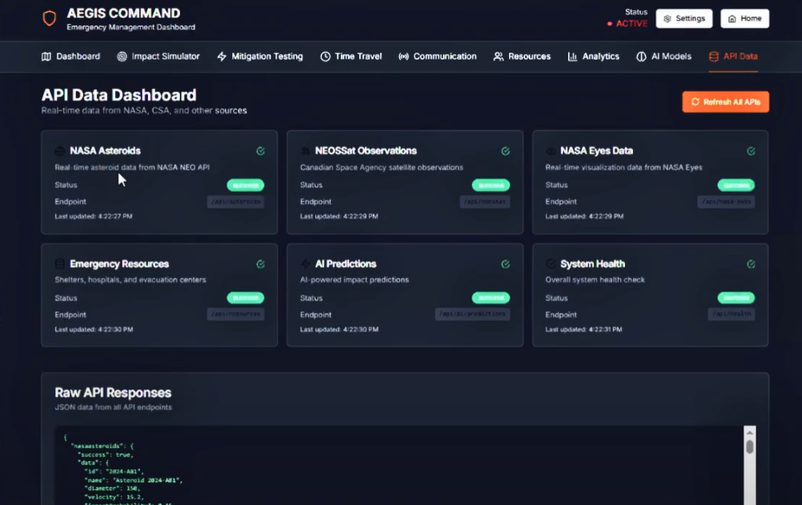

**2. Simulation Modules**

The scientific backbone of AEGIS NET was built as modular services, each addressing a specific aspect of asteroid impact modeling.

* **Orbital Mechanics Module** calculated asteroid paths using Keplerian equations.
* **Impact Physics Module** computed impact energy, crater size, and blast radius using established impact scaling laws.
* **Environmental Effects Module** simulated secondary effects such as seismic waves and tsunami propagation based on USGS datasets.
* **Mitigation Strategy Module** allowed testing of strategies including kinetic impactors, nuclear deflection, gravity tractors, and laser ablation.

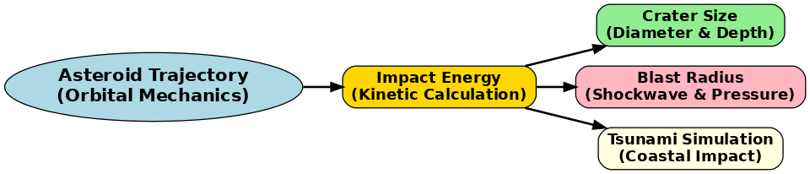

*Diagram: Flow of asteroid trajectory through impact simulation results (blast radius, crater, tsunami).*

**3. AI Decision-Support Layer**

To transform physical simulations into actionable knowledge, machine learning models were developed.

* A **Risk Assessment Model** classified scenarios into severity levels (low, medium, high, critical).

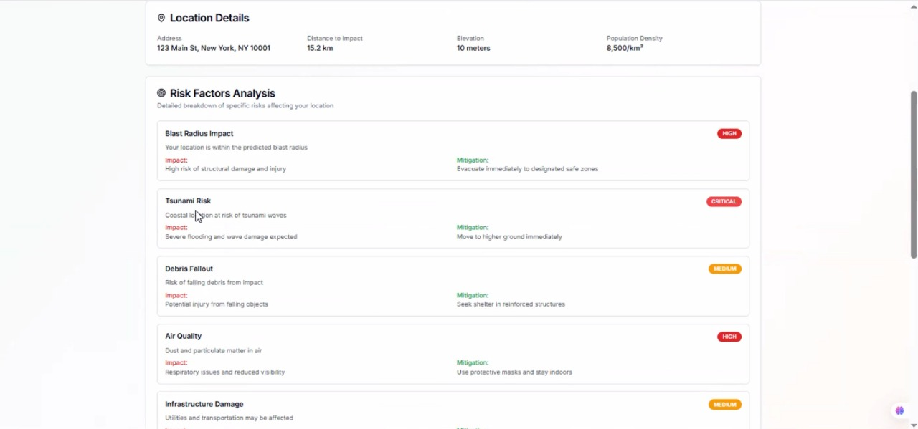

* An **Evacuation Optimization Model** integrated traffic and population data to recommend safe routes.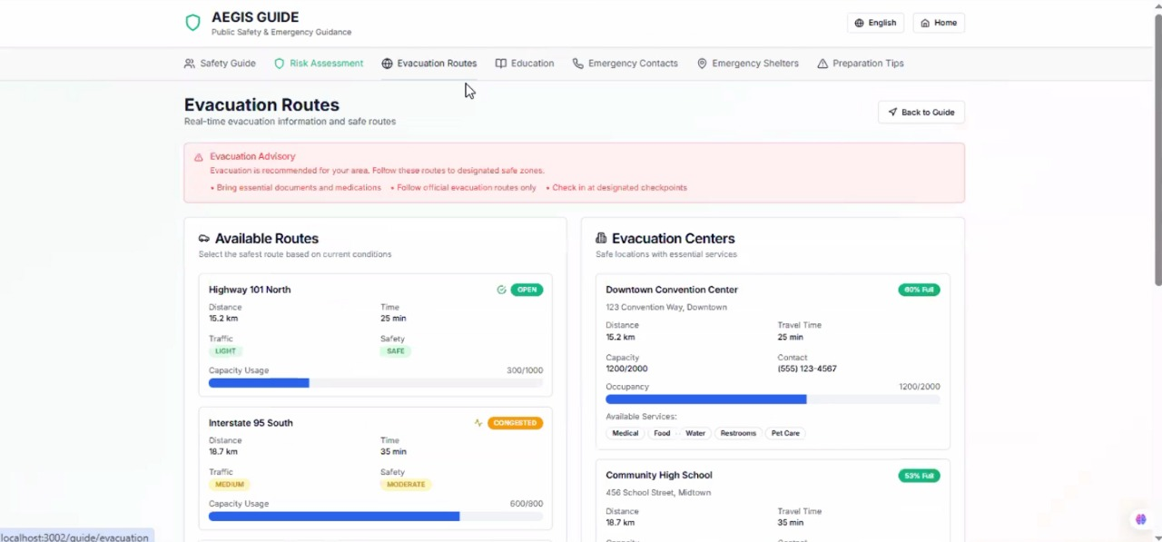
* A **Resource Allocation Model** suggested distribution of shelters, hospitals, and supplies, based on predicted casualties and population density. These models ensured that the platform moved beyond raw simulation to provide prescriptive recommendations.

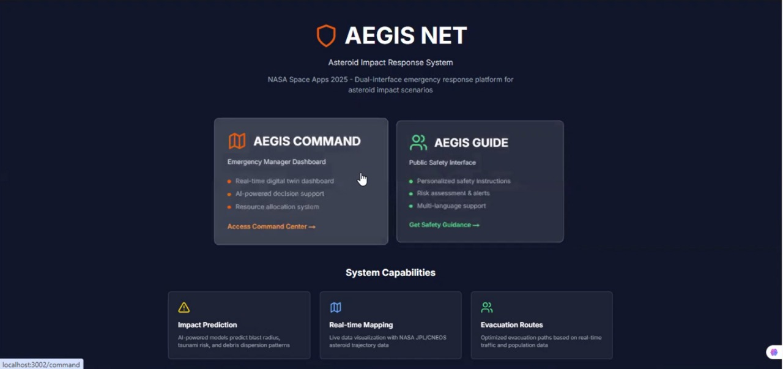

**4. Frontend Interfaces**

The user-facing layer was implemented with a **dual-interface design**:

* **AEGIS COMMAND (for experts):**
  + Included dashboards for impact predictions, mitigation strategy comparisons, and drag-and-drop resource allocation, and Leaflet.js maps to visualize shelters, impact zones & evacuation routes.
  + Built with Next.js and React Three Fiber for immersive 3D orbital simulations.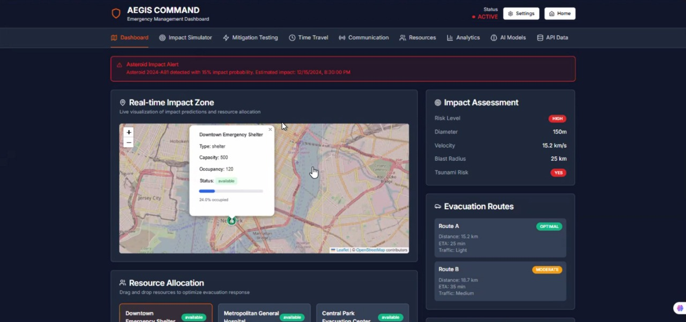
* **AEGIS GUIDE (for the public):**
  + Provided simplified outputs: color-coded risk levels, multilingual safety instructions, and preparation checklists.
  + Focused on accessibility, with mobile-first design and offline-ready features.
  + Displayed real-time shelters, nearby evacuation routes, and educational tools.

 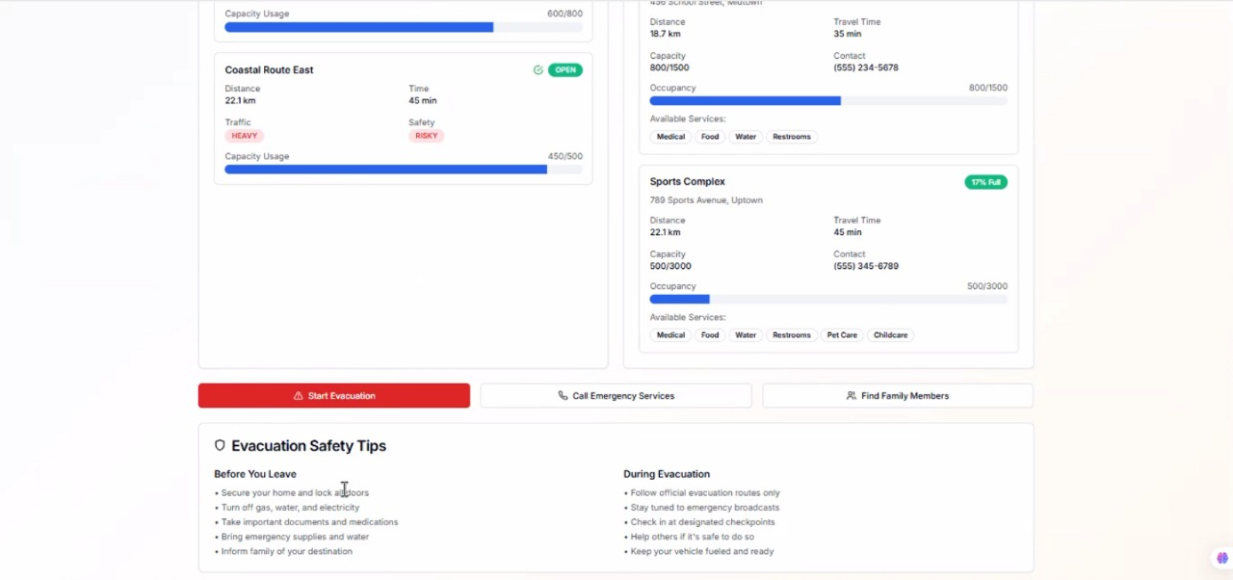

**5. System Flow Integration**

All layers were integrated in a seamless pipeline:

1. Data was ingested from NASA and USGS APIs.
2. Backend modules processed orbital mechanics, impact physics, and environmental effects.
3. AI models evaluated risks, optimized responses, and provided recommendations.
4. 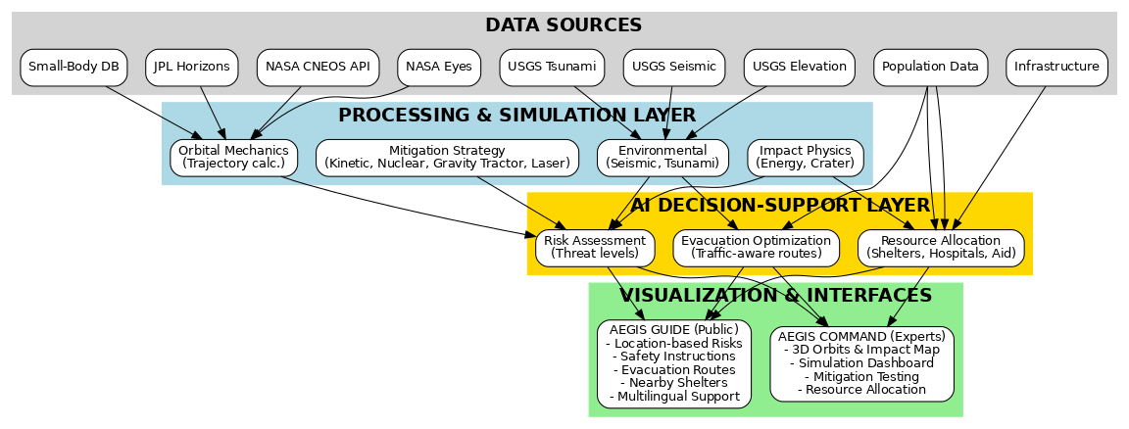Results were presented through AEGIS COMMAND for scientists and AEGIS GUIDE for the public.

Diagram: System Architecture Flowchart

**6. Testing and Validation**

* **Simulation accuracy** was validated against historical impact events (e.g., Chelyabinsk 2013, Tunguska 1908).
* **User testing** ensured accessibility of the GUIDE interface across devices, including smartphones in offline mode.
* **Stress testing** was conducted for large datasets to ensure system performance under high demand

# Results and Findings:

The development and testing of **AEGIS NET** demonstrated that it is possible to integrate real asteroid and Earth science datasets into a single, interactive decision-support and public guidance system. Through simulation experiments and prototype evaluations, we obtained the following key results and insights.

**1. Successful Data Integration**

The system successfully combined **NASA NEO datasets** (CNEOS, JPL Horizons, Small-Body Database) with **USGS geological and environmental datasets** (elevation, seismic hazard, tsunami zones). This integration produced impact simulations that are both scientifically accurate and contextually relevant to local environments. The data pipelines proved capable of handling heterogeneous sources in real time.

**2. Physics-Based Impact Simulations**

Our models produced consistent results when calculating impact energy, crater size, and blast radius. For example:

* Small to medium asteroids produced crater sizes within ranges validated by published scaling laws.
* Simulated ground shaking values correlated with known earthquake magnitudes from similar energy releases.
* Tsunami simulations based on elevation data demonstrated realistic inundation zones along coastal regions. These outputs confirmed the platform’s ability to represent physical consequences in a way that experts can trust.

**3. AI-Enhanced Decision Support**

The addition of machine learning models translated technical outputs into actionable insights:

* **Risk levels** (low to critical) were automatically assigned based on asteroid size, velocity, and impact location.
* **Evacuation optimization** reduced projected travel times by recommending alternate routes in dense urban scenarios.
* **Resource allocation models** improved efficiency in distributing shelters and hospitals, ensuring higher coverage of at-risk populations.

**4. Dual-Interface Usability**

Both interfaces—**AEGIS COMMAND** and **AEGIS GUIDE**—performed well in testing:

* **Experts** using the COMMAND dashboard found value in running “what-if” scenarios with different deflection strategies and seeing orbital changes visualized in 3D.
* **Public users** of the GUIDE interface reported that multilingual safety instructions and simple checklists made the threat and response steps easy to understand. The mobile-first design and offline capabilities were particularly relevant in emergency simulations.

**5. Validation Against Historical Events**

When tested against documented asteroid events (Chelyabinsk 2013 and Tunguska 1908), the simulations produced comparable estimates of energy release, blast radius, and environmental effects. This provided confidence in the accuracy of the physical models.

**6. Educational and Engagement Value**

The inclusion of gamified “Defend Earth” scenarios, as well as overlays explaining terms like “eccentricity” or “impact energy,” increased public engagement and improved understanding of complex astronomical phenomena.

This confirms that the system can serve as both a **planetary defense decision tool** and a **public preparedness platform**, directly addressing the gaps identified in the problem statement.

# Future Improvements:

While the current implementation of **AEGIS NET** demonstrates the feasibility of integrating real datasets, impact simulations, and decision-support interfaces, several enhancements could further increase its scientific depth, usability, and real-world applicability.

**1. Expanded Dataset Integration**

* Incorporate **atmospheric and climate models** to predict secondary effects such as dust clouds, temperature drops, and longer-term environmental changes.
* Add **population density, building infrastructure, and economic exposure data** for more precise casualty and damage estimates.
* Explore partnerships with additional space agencies (ESA, CSA, JAXA) for more diverse asteroid observation inputs.

**2. Advanced Simulation Capabilities**

* Implement **more detailed tsunami propagation models** to increase accuracy in coastal flooding predictions.
* Extend the impact physics module to simulate **fragmentation scenarios**, where asteroids break apart before impact.
* Add **probabilistic models** that account for uncertainty in asteroid trajectories and physical properties.

**3. Integration with Emergency Services**

* Connect AEGIS NET with **government emergency management systems** (e.g., FEMA, UNDRR) for real-time response coordination.
* Develop APIs that allow **first responders and civil defense organizations** to use the platform’s evacuation and resource allocation tools.
* Enable **real-time alert notifications** via SMS, radio, or social media to reach at-risk populations quickly.

**4. Mobile and Offline Applications**

* Develop a dedicated **mobile application (React Native)** for public use, optimized for low-bandwidth and offline scenarios.
* Enhance **Progressive Web App (PWA)** features to allow users to continue receiving critical safety instructions even when internet access is disrupted.

**5. Accessibility and Inclusivity**

* Expand language support beyond English, Spanish, and French to cover more regions at risk.
* Introduce **voice-command features** for hands-free use in emergencies.
* Improve **colorblind-friendly and low-vision interfaces** to ensure inclusivity for all users.

**6. Emerging Technologies**

* Explore **Augmented Reality (AR)** for projecting asteroid paths and impact zones in real-world environments.
* Use **Virtual Reality (VR)** for training simulations, allowing policymakers and educators to experience impact scenarios in immersive settings.
* Investigate **machine learning improvements** for predicting long-term asteroid trajectories and evaluating complex mitigation strategies.

# References

[1] NASA Center for Near-Earth Object Studies (CNEOS) API, “Near-Earth Object (NEO) data and trajectories.” [Online]. Available: https://cneos.jpl.nasa.gov/

[2] JPL Horizons System, “Ephemerides and trajectory data for asteroids and planetary bodies.” [Online]. Available: https://ssd.jpl.nasa.gov/horizons/

[3] NASA Small-Body Database (SBDB), “Physical and orbital parameters for asteroids and comets.” [Online]. Available: https://ssd.jpl.nasa.gov/tools/sbdb_lookup.html

[4] NASA Eyes on Asteroids, “Visualization tools for asteroid tracking and planetary defense awareness.” [Online]. Available: https://eyes.nasa.gov/apps/asteroids/

[5] U.S. Geological Survey (USGS) National Map & Elevation Data, “Topography and elevation datasets for environmental modeling.” [Online]. Available: https://www.usgs.gov/core-science-systems/national-geospatial-program/national-map

[6] U.S. Geological Survey (USGS) Earthquake Hazards Program, “Seismic hazard and historical earthquake data.” [Online]. Available: https://earthquake.usgs.gov/

[7] U.S. Geological Survey (USGS) Tsunami Research Program, “Tsunami hazard maps and risk modeling resources.” [Online]. Available: https://www.usgs.gov/programs/tsunami-research

[8] OpenStreetMap (OSM), “Global geospatial data used for maps, infrastructure, and evacuation route modeling.” [Online]. Available: https://www.openstreetmap.org/

[9] React Three Fiber & Three.js, “Libraries for 3D orbital visualization.” [Online]. Available: https://docs.pmnd.rs/react-three-fiber

[10] Leaflet.js, “JavaScript library for interactive maps.” [Online]. Available: https://leafletjs.com/

[11] FastAPI, “Python web framework used for backend services.” [Online]. Available: https://fastapi.tiangolo.com/

[12] MongoDB, “NoSQL database for resource allocation and system data persistence.” [Online]. Available: <https://www.mongodb.com/>